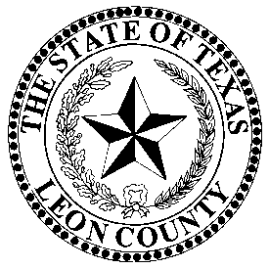 | LEON COUNTY ELECTION’S OFFICE
 | Donna Golden, Election Administrator, REO, CERA
 | P.O. Box 1239, 155 N Cass Street, Centerville, Texas 75833 903/536-4469 903/536-1773-FAX

March 31, 2023

Public Notice of Election School

Election school for the May 6, 2023 City/School General & Special Elections will be held at 1:00 P.M. on Thursday, April 19th, 2023 on the 3rd floor of Annex II at 155 N. Cass, Centerville, TX.

If more information is required, please contact Donna Golden, Election Administrator, REO, CERA at 903-536-4469.

